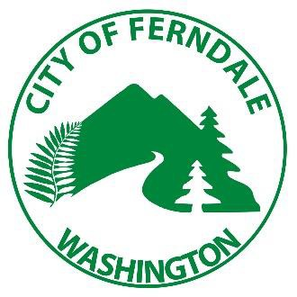
City of Ferndale

CITY COUNCIL STAFF REPORT

SUBJECT:

DATE:

FROM:

PRESENTATION BY:

RECOMMENDATIONS:

BACKGROUND:

ANALYSIS:

ALTERNATIVES CONSIDERED:

FISCAL REVIEW:

LEGAL REVIEW:

CONCLUSION:

LEGAL REVIEW:
Ferndale Municipal Code 10.08.030 establishes Council’s authority to authorize the
Public Works Director to install signage limiting or prohibiting parking.

CONCLUSION:
Staff recommends approval of the resolution as presented.

RESOLUTION NO.

A RESOLUTION OF THE CITY COUNCIL OF THE CITY OF FERNDALE, WASHINGTON, ESTABLISHING PARKING RESTRICTIONS ON PORTAL WAY

WHEREAS, the City of Ferndale, Washington (hereinafter “City”) has received multiple complaints regarding parking issues on Portal Way; and

WHEREAS, the City Council is authorized through Ferndale Municipal Code 10.08.030 to empower the Public Works Director to install signage limiting or restricting parking; and

WHEREAS, the City Council desires to improve public safety on Portal Way by implementing parking restrictions.

NOW, THEREFORE, BE IT RESOLVED BY THE CITY COUNCIL OF THE CITY OF FERNDALE, WASHINGTON, THAT:

The Director of Public Works is authorized to install and maintain signage restricting parking on Portal Way, including:

• Time restricted parking;
• No commercial vehicle parking;
• No parking.

The Director of Public Works is further authorized to utilize professional discretion in cooperation with the Ferndale Police Department to determine the location and type of restrictions.

APPROVED AND ADOPTED by the Ferndale City Council this 1st day of April, 2019

Attest:

Jon Mutchler, MAYOR Susan Duncan, CMC, City Clerk

1

