PIONEER PAVILION COMMUNITY CENTER
FACILITY USE AND RENTAL INFORMATION SHEET

Anya Milton, Facility Manager
2007 Cherry St., Ferndale, WA 98248
Phone (360) 384.3042 or (360)441-3797
Email: Pavilionrentals@gmail.com
www.PioneerPavilion.com

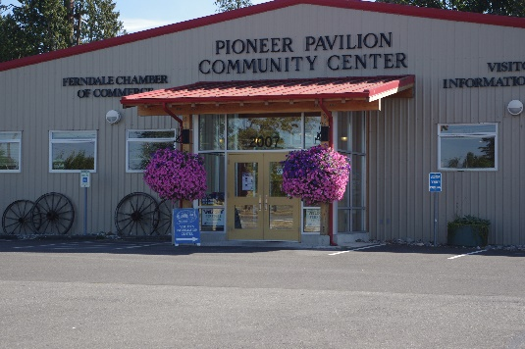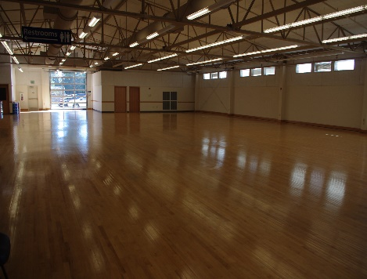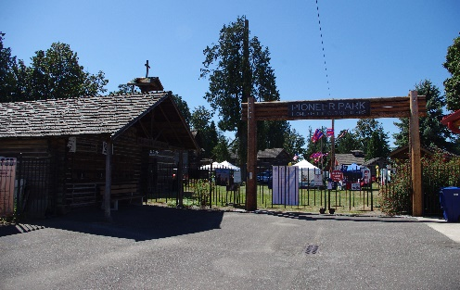

Hello and thank you for your interest in renting Pioneer Pavilion. The Pavilion is located next to Historic Pioneer Park with it’s beautiful log buildings in downtown Ferndale, WA. Renting this facility is done through the Ferndale Chamber of Commerce, located at the facility.
The Pavilion is a 6,000 square foot rental facility. It currently includes chairs and tables for 300 guests, restroom facilities and plenty of parking. It has an AV system with AirMedia®, full drop-down screen (18’ x 9’), wireless and wired microphones, podium & excellent sound system.
If you are looking to utilize the location for a wedding, consider having your wedding in the Park and your reception in our facility.
There is a catering kitchen that has a commercial fridge, small upright freezer, triple sink, two 100-cup coffee makers, microwave and lots of counter space with a pass-through window into the Pavilion.
In order to rent this facility, it is best to check the on-line calendar to make sure your event date is available, then fill out the on-line application and depending upon your date and reserve the facility with a minimal deposit (see application for details). To secure renting the facility, you will need to pay a $500 security deposit, of which $110-$140 is non-refundable for cleaning, or a reservation deposit. Rental rates are attached.
If you are having a public event that serves alcohol, you will be required to hire two off duty police officers at a rate of $65/hour per officer. WSLCB rules and rates will apply as will having liquor liability coverage.
Prior to your event, you will do a walk-through of the facility and be set up to get keys from the City. All applications must go through the facility manager. No rental will be approved without a fully filled out rental agreement signed by you and the facility manager.
If you have any questions regarding this rental, please feel free to email or call the number above. Our office hours are 9 am to 5 pm, Monday through Friday and we are closed for all legal holidays.
We hope that you find our facility a perfect place for your event, big or small and we look forward to working with you.
Sincerely,

Anya Milton
Facility Manager

