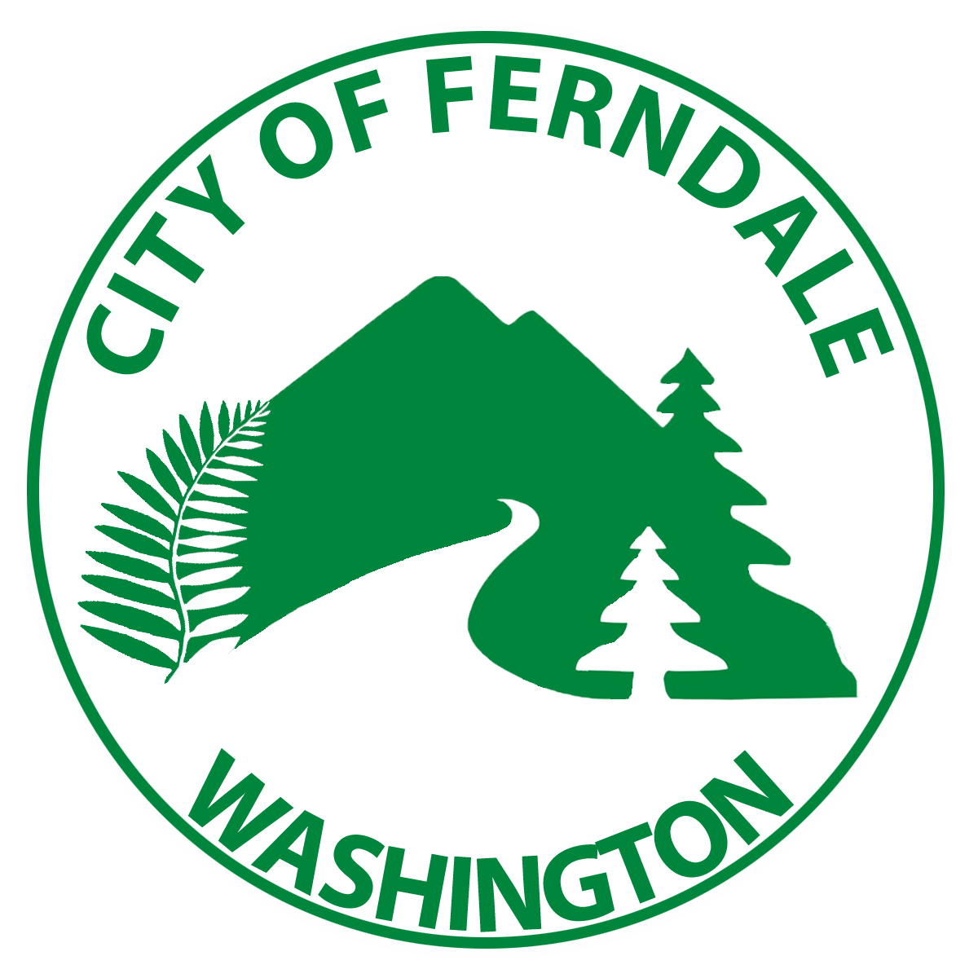

North Whatcom Poverty Task Force
Michelle Beck
Tom Black
Jim Carr
AGENDA
Wednesday, August 7th, 6pm
City Annex, Council Chambers
Owen Cool – Vice-Chair
Autumn Cunningham - Chair
Councilmember Kate Hansen
Ali Hawkinson
Sarah Koehler
Mark Kruetzkamp
Sara O’Connor
Riley Sweeney - Staff

A. Call to Order Vice-Chair Owen Cool

B. Approval of Agenda and Minutes Task Force Members

C. Introduction of Transportation Issues Task Force Members

D. Whatcom Transportation Authority WTA

E. Discussion Task Force Members

F. Public Comment Members of the Public

G. Homework for Next Meeting Riley Sweeney

ITEMS SCHEDULED FOR NEXT MEETING
City Hall Main Conference Room – 2095 Main St.

Next Meeting – Emergency Weather

